UNIVERSITY OF RWANDA
COLLEGE OF SCIENCE AND TECHNOLOGY
soICT
COMPUTER SCIENCE
LEVEL 3
MODULE: Computer graphics

ASSIGNMENT 2

Group7:

USANASE Emeline 222008798
NISINGIZWE Marie Claire 222008836
IZERE BUGINGO Vainqueur 222019837
NSENGIYUMVA Clement 222005281
MUKUNZI Emmanuel 222019777

Note: All code snippets referenced in this document are available on the GitHub repository Computer graphics.

QUESTION 1:
A. The following are java codes draw line in a swing using bresenham’s line algorithm.
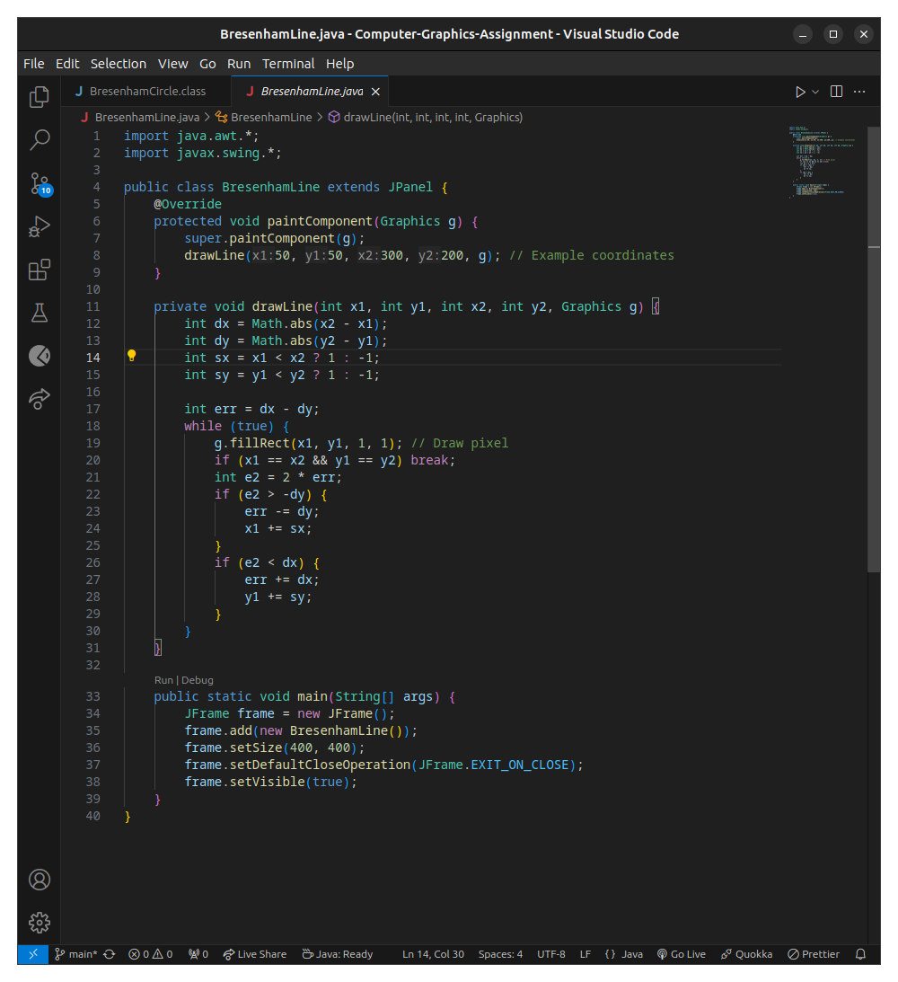
Here is the output
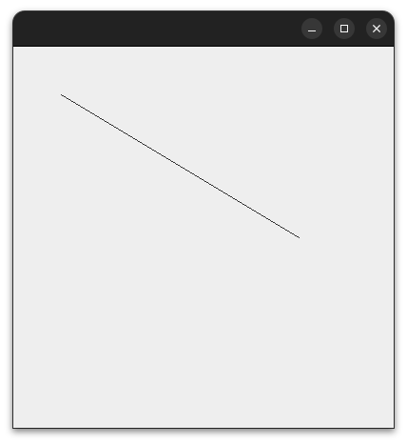

B. In figure bellow is the java codes that draw a circle following Berensham’s circle algorithm, alongside their output.
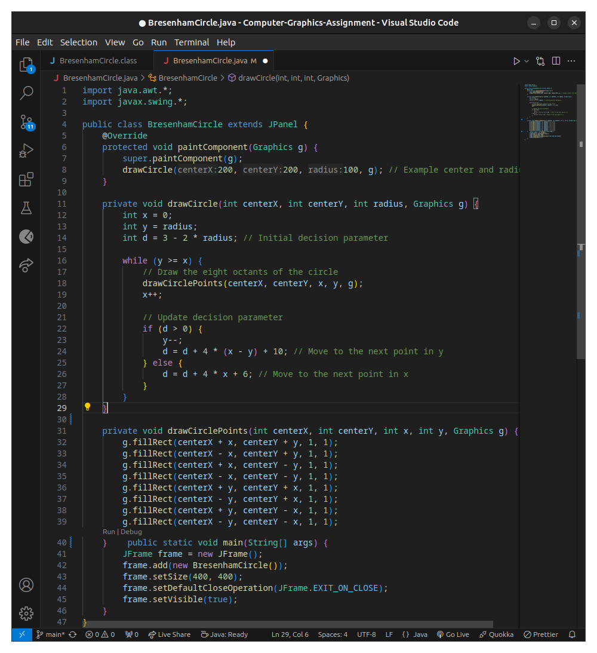
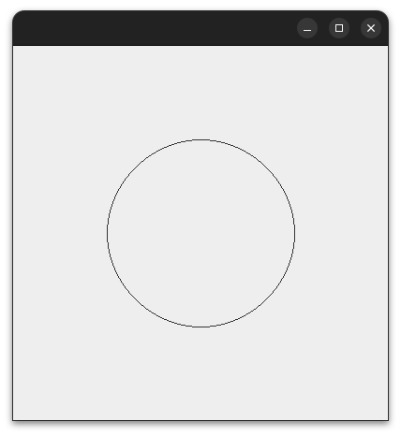

QUESTION 2:
Here is python codes that generate 3D plot of a torus surface defined by parametric equations, visualized with color map and labeled axes.
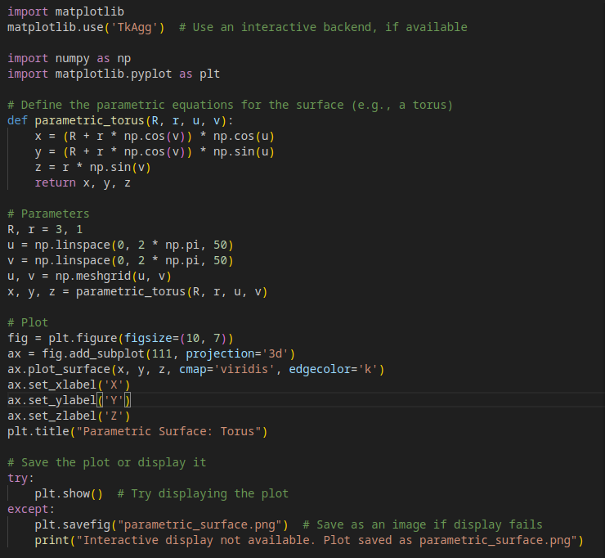

And here is the output.

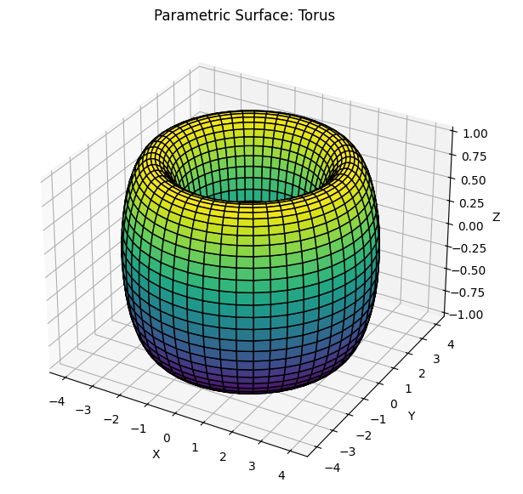
QUESTION 3:

On this question all codes are written in python

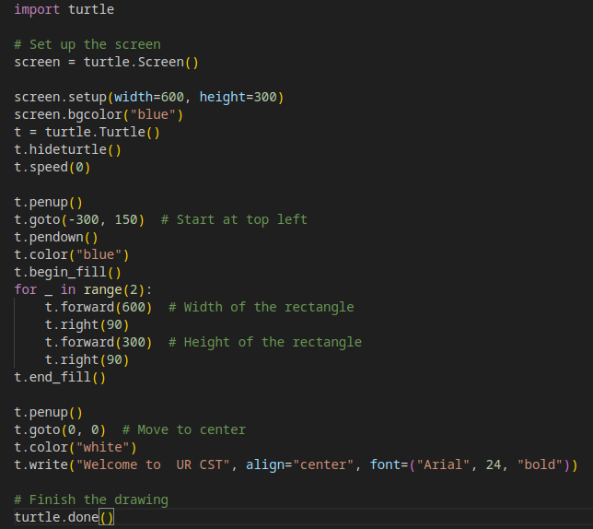

Output
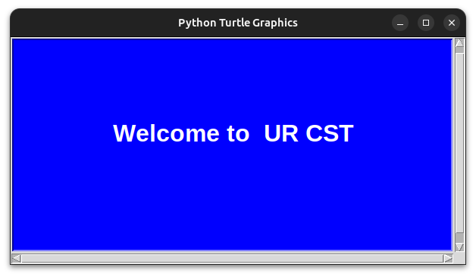
B.

Codes:

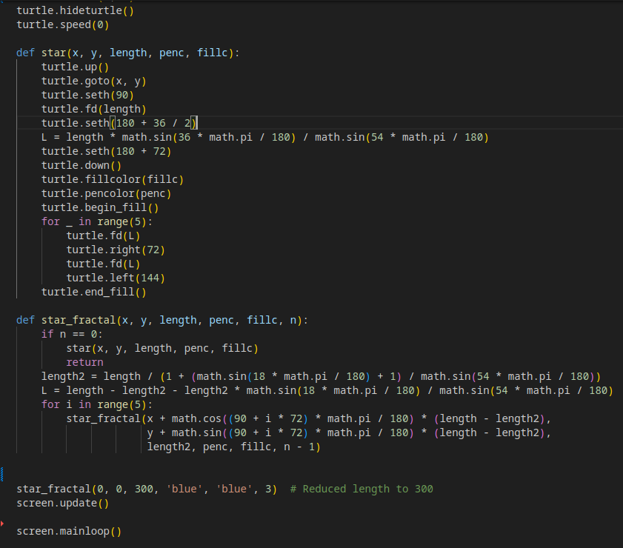

Output:

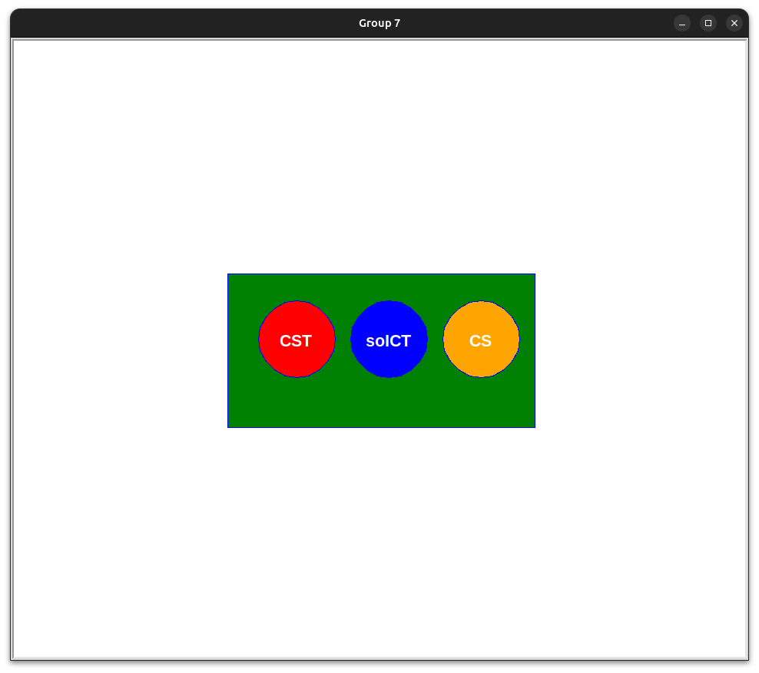

C.

Codes

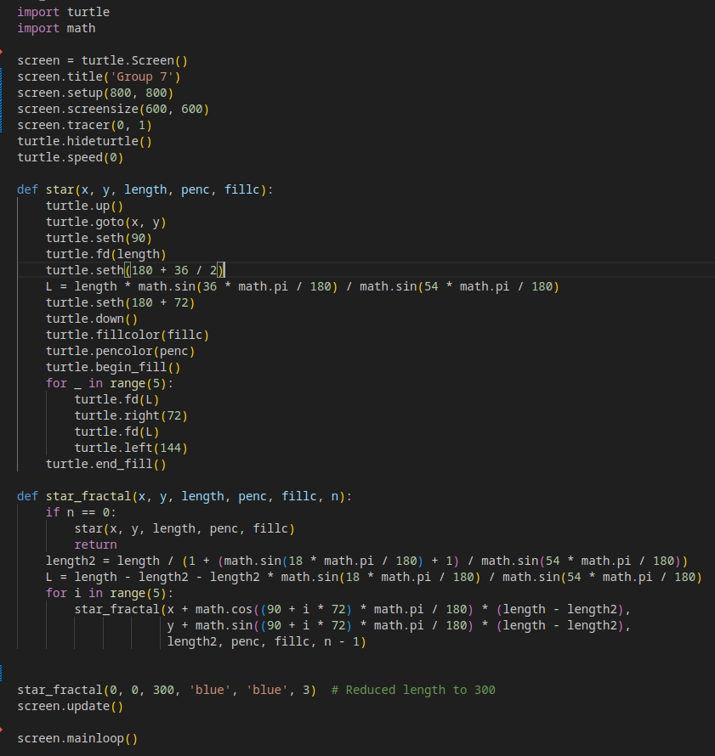

Output:
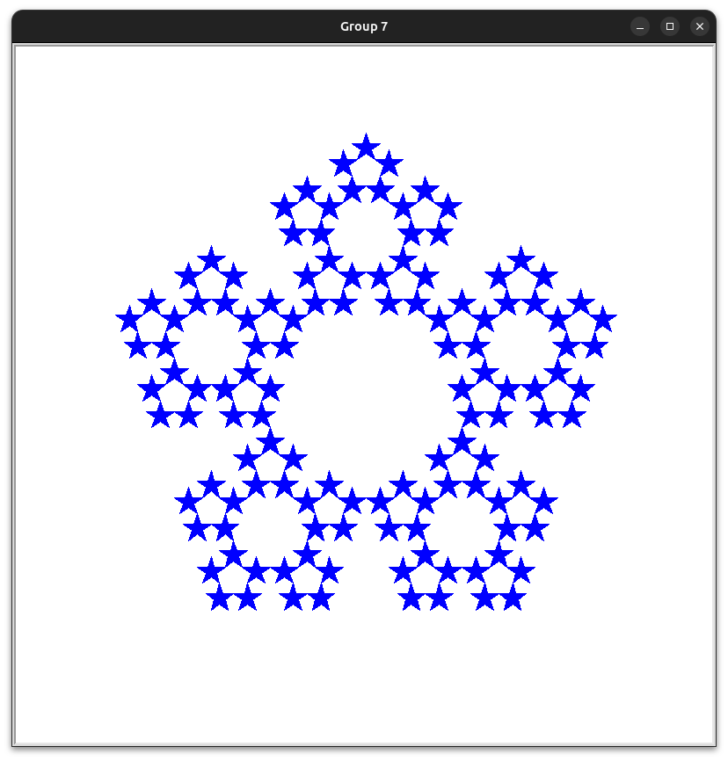

D.

Codes:

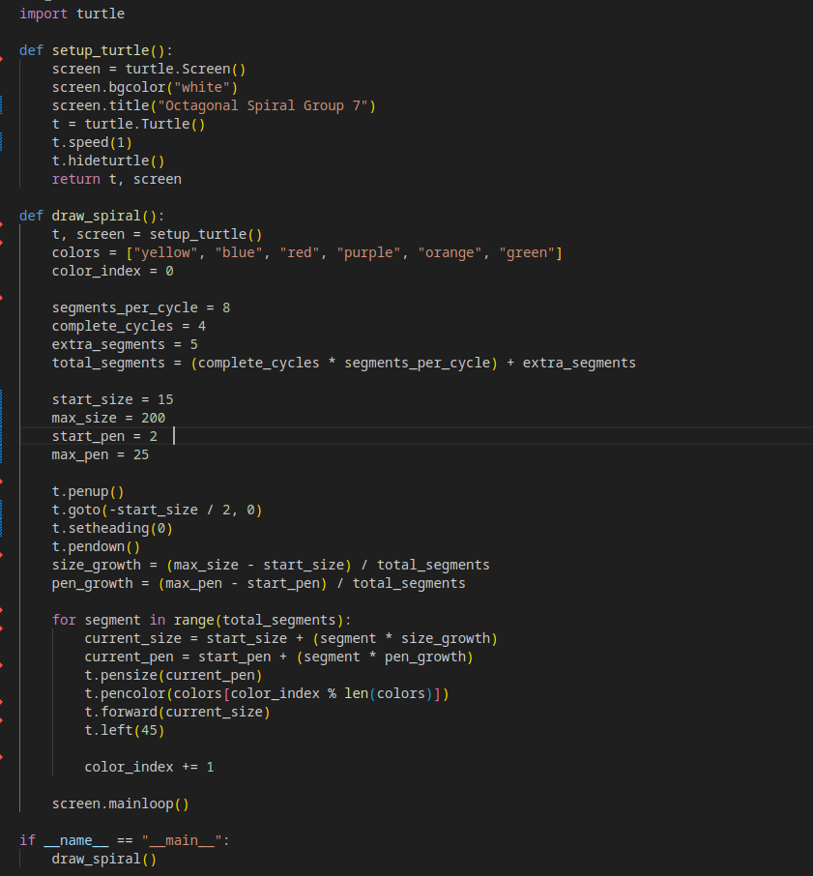

Output:

